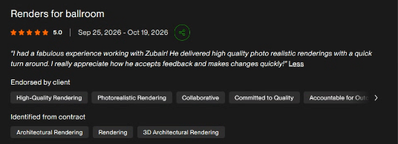
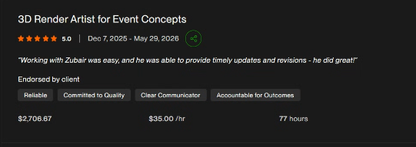
I have recently been working with a Creative Group, an event planning company specializing in experience design for meetings, incentive programs, and brand activations that drive real business results. I created multiple 3D event visualization options for their projects, including three alternative design renders for a single event, helping the team present different concepts and directions to their clients. This has developed into an ongoing collaboration, and I regularly work with them on various types of event renders and spatial concepts.
Client website:
https://creativegroupinc.com/
This is the first review project:
Option A B C
This is the second:
https://drive.google.com/open?id=1jYxBTc3m3Mo3cnIUEOiY3vMKvkosfrrh&usp=drive_copy
https://drive.google.com/open?id=1ZSThwVlI0ljg60KinsSCCD7pb10RUqT3&usp=drive_copy
https://drive.google.com/open?id=1MS9pGp8eG3zBvbz8AgDclV5fPBj584AO&usp=drive_copy
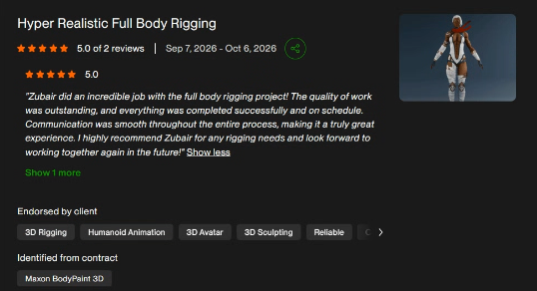
final look
details
Reference
The project involved the complete 3D creation and technical preparation of a stylized fox character for real-time use. I was responsible for modeling the character while maintaining a 50,000-polygon budget, ensuring an optimized mesh with clean topology and suitable geometry for deformation and real-time performance. Following the modeling stage, the character required a complete rigging setup, including skeleton creation, weight painting, and proper deformation of the body, limbs, head, ears, and tail. The final stage involved converting the rigged character into the VRM format, including humanoid bone mapping, configuring additional bones for fox-specific features, and setting up secondary motion using VRM Spring Bones where required. The objective was to deliver a fully modeled, rigged, optimized, and VRM-compatible fox character, ready for integration into VRM-supported applications and real-time avatar environments.

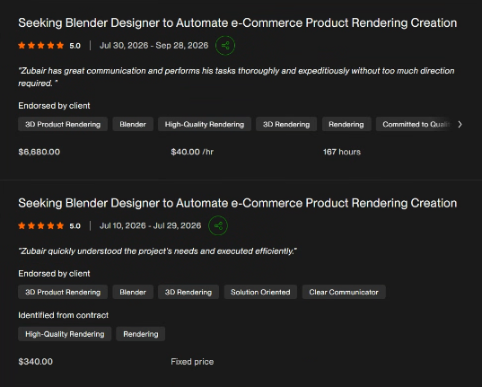
Gun part
https://zaffiriprecision.com/
The project involved extensive 3D modeling, product visualization, and animation work for Zaffiri Precision, specializing in detailed firearm components and precision-machined parts. My responsibilities included creating accurate 3D representations of individual components, maintaining precise geometry, surface details, and material finishes to achieve high-quality product visuals. Over the course of the collaboration, I produced 5,000+ product renders using custom-built production pipelines that automated and streamlined the rendering process, significantly improving workflow efficiency and supporting large-scale product visualization requirements. In addition to still renders, I also developed product animations showcasing component details, design features, and product functionality. The workflow combined precision 3D modeling, customized automation, high-quality rendering, and product animation to support the company's extensive product presentation needs.
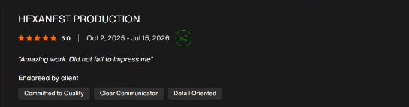
Adam:
AI Architectural Configurator:
https://adamaitest.techversoldevops.com/
Floor plan you can use for yourself:
https://drive.google.com/open?id=11-nVo1nQsXh2xF9zVIfyUrWHKTH9rKV8&usp=drive%5Fcopy
Demo: https://drive.google.com/open?id=1hbPQFiXl-utznwRtuCaU8%5Fb4Oey2jhdR&usp=drive%5Fcopy
Configurator:
https://drive.google.com/open?id=1i8E2NQJ-HXheR4knDb2uGAHVyOsO1lP3&usp=drive%5Fcopy
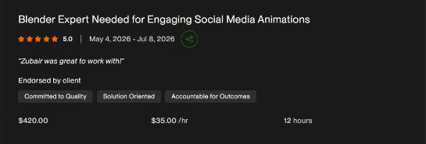
https://mnstrassoc.com/
https://drive.google.com/drive/folders/1NkuzgwUCr6866CZvvdpBxUoG-ec-DMNm?usp=drive_link
The project involved creating high quality 360° product animations for MNSTR Assoc, featuring their anime-inspired jewelry collections. The client required detailed mesh renders and rotational product animations to showcase the jewelry designs from every angle. My work focused on preparing and presenting the 3D jewelry assets with accurate geometry, proportions, and fine design details, ensuring each piece was clearly visible throughout the animation. I developed 360° production animations that highlighted the jewelry's overall form, craftsmanship, and design elements, creating polished product visuals for e-commerce and marketing. The objective was to deliver engaging, professional product animations that let customers explore the jewelry designs from a full 360 ° view.
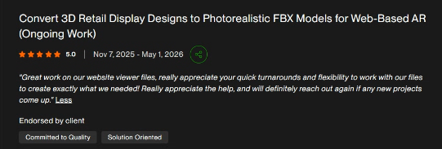
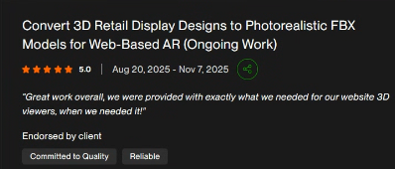
https://bordertownretail.com/
Bordertown Retail – 3D Modeling & AR-Ready Assets
Created detailed 3D model libraries of retail racks and display systems, including FBX assets prepared for an AR visualization platform.
https://drive.google.com/drive/folders/1VLxPD8gOAJAkuUjMNWVr0bngN-cxUJ7N?usp=drive_link
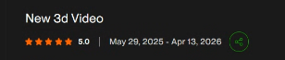
https://drive.google.com/open?id=1T2NQzOgKuVF6qYmPxnhCzme8LvDZpc37&usp=drive_copy
https://gooplast.com/en/
The project involved creating 3D product animations for GooPlast, a company specializing in innovative plastic-based construction solutions and formwork systems. My responsibility was to develop animations that clearly demonstrated how their products work, how individual components are assembled, and how the systems are integrated into real construction applications. The animations focused on visually explaining product functionality, installation procedures, structural applications, and the interaction between different components. This included showcasing construction systems such as plastic formwork and voided slab solutions through detailed 3D sequences, illustrating the installation process, reinforcement placement, concrete pouring, and the final structural result. The objective was to transform complex construction processes into clear, engaging visual demonstrations that help engineers, contractors, and potential customers understand the products, their applications, and their practical benefits.
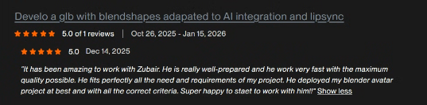
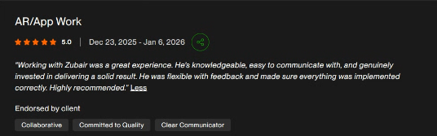
Artscapes:
I have recently developed the artscapes AR app for Android and iOS using Unity3D and C#. The application uses Vuforia, ARCore/ARFoundation, and ARKit to deliver real-time augmented reality experiences across both platforms. I handled the complete development pipeline including AR scene setup, tracking, interaction logic, and optimization for smooth performance on mobile devices.
https://artscapes.co/
Playstore:
📌https://play.google.com/store/apps/details?id=com.ScanscapesTech.ArtScapesAR&hl=en%5FUS
IOS:
📌https://apps.apple.com/us/app/artscapes/id1433059246
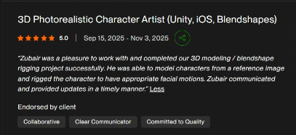
Before/After:
https://drive.google.com/open?id=1RoGL62BZ01abPm63Mcu7aPxC%5FDa-VM3Q&usp=drive%5Fcopy
Video showcase:
https://drive.google.com/open?id=12hTlOHBFaMhWlL5Wv1FszRI--Y6LzsKf&usp=drive%5Fcopy
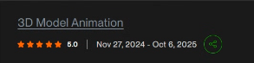
Created model and aniamtion for AR use showcasing the machine working
https://www.macrovey.com/
Macrovey University 2.mp4
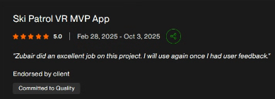
Created a VR traning sim of how a medical personal will acrry out action of someone injured during siking the action involved CPR basic checkup bandaging and putting the paitent on an stecther and attaching it to helicopter.
https://drive.google.com/open?id=1MyqRgAY_qx1XRKk0QSAzEfjXS9mym49q&usp=drive_copy
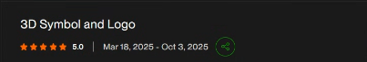
https://drive.google.com/open?id=1OLstcnhdnInphB6CCaVGTrwfJ5ouJYNE&usp=drive_copy
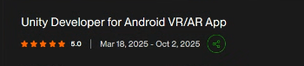
Created a hosue walkthrough in VR client can select materail to change involves interatction with house hold items and funriture
Neil-MR-Walkthrough.mp4
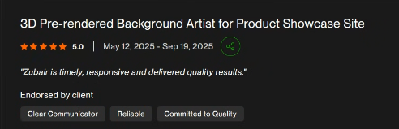
Showcase porducts in booth enviornment of how it would look in the event
https://drive.google.com/drive/folders/1oBzcHg92ICEtfkg_ffVbGtNp-adNAbCs?usp=drive_link
https://dwspectrum.com/page/dw-mobile/
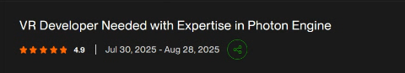
made a meeting experience where users can join remotley as if they are inside the meeting room showcase the material they have basically a fully meeting environemnt.
VID-20260127-WA0060.mp4
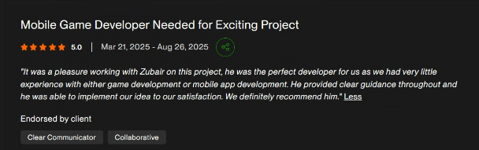
Dandy Shandy:
Demo:
https://drive.google.com/open?id=1qhWmaNGUDpF9XWni3fXp137ooMXI9PHp&usp=drive%5Fcopy
Play Store:
https://play.google.com/store/apps/details?id=com.DandyShandy.com.unity.template.mobile2D&hl=en%5FUS
Screens:
https://drive.google.com/drive/folders/19FMGtKXFW26HB%5Fp6ZRqb7NmF88PEq4aN?usp=drive%5Flink
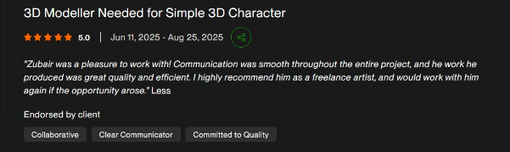
Zebra mascot
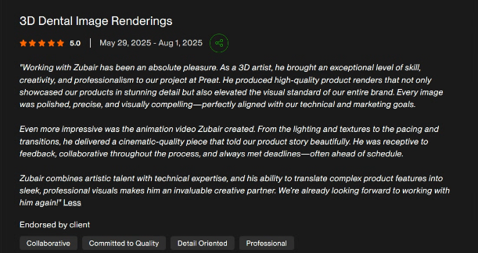
Created product librabarie of aniamtion and renders for dental technology products for Preat.
3. Rachael Dental Product (Final - Correction)_Final 5.mp4
https://www.preat.com/
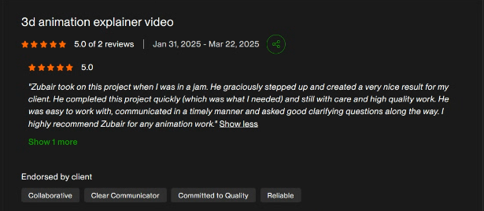
https://intelliroad.com/tolling/
https://drive.google.com/open?id=1fqZJ0bah0OXDCuWz2KT9o5ifImdu6VjQ&usp=drive_copy
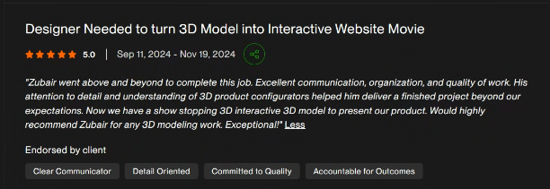
Engo Planet Website:
📌 https://www.engoplanet.com/
📌 https://www.engoplanet.com/engo-custom-solar-products (Render Uploaded)
Blue Bird Solar Bench Configurators:
📌 https://playcanv.as/e/b/71442ed8
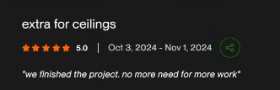
https://drive.google.com/drive/folders/1lYQak5bdDtkM28vec788alzPLkT5UacJ?usp=drive_link
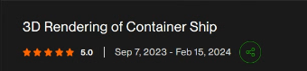
https://drive.google.com/drive/folders/1XBDsHltgAp29R3mwXKNJVkfte-iRwBeE?usp=drive_link

